**Objective Questions**:

1. **What is the total no. of tables present in the data?**

**Ans** : There is only one table present in the data

1. **What is the total no. of attributes present in the data?**

**Ans** : **35**

1. **The data consists of some inconsistent and missing values so ensure that the data used for further analysis is cleaned.**

**Ans** :

* There is no duplicate values found in the dataset
* Did some extraction on **CreatedAt, UpdatedAt** Column
* A screenshot of a computer

  AI-generated content may be incorrect.I have taken **Days** And **Months** from date column
* There are some columns in the data which are not useful

1. **What is the average daily call volume over the day by day and what’s the change on it?**

**Ans :** 246.029 is the average daily call volume

Calls are decreasing in longer term that the change

Pivot table shown below:

1. **Which months experienced the highest and lowest call volumes?**

**Ans :**

* December (2023) month has highest call volum
* January (2024) month has lowest call volume

1. **What is the total operational cost for that month?**

**Ans :** 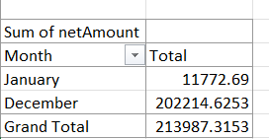

Taken net amount as operational cost

1. **What is the average number of calls handled per agent per day?**

**Ans**

* **Count of Unique Guru IDs**: A pivot table was utilized to determine the unique count of guru_id values, providing a total number of unique agents involved.
* **Count of Calls**: To calculate the total number of calls, the following formula was applied:

=COUNTIF('Working Sheet'!K:K,"Call") + COUNTIF('Working Sheet'!K:K,"public_live_call")

This formula counts all instances of "Call" and "public_live_Call" within the designated column k of the data sheet, ensuring accurate aggregation of both types of call events.

* **Count of Days**: The unique count of days was determined by extracting distinct values from the date column and then applying the COUNT function. Using the formula:

=COUNTA(UNIQUE(R2:R28028))

* **Calculation of Average Calls Handled Per Agent Per Day**: The average number of calls managed per agent daily was determined using the formula:

Count of calls/(count of guru id * count of days) **= 1.91** Calls are handled per agent per day

1. **How many repeat callers are there, and what percentage of total calls do they represent?**

Ans : 1275 repeat callers are there

Applied SUMIF,COUNTIF function on the pivot tables column

Detailed solution with pivot table is provided in excel (objective worksheet)

Percentage of Total Calls by Repeat Users=

(Total CallsCalls Made by Repeat Users​)×100/Total calls

Percentage of total calls made by repeat users is 4737/8365 *100 **= 56.6%**

1. What is the total sales generated by the call centre for each product category?

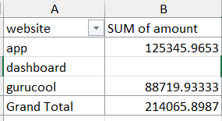**Ans :**

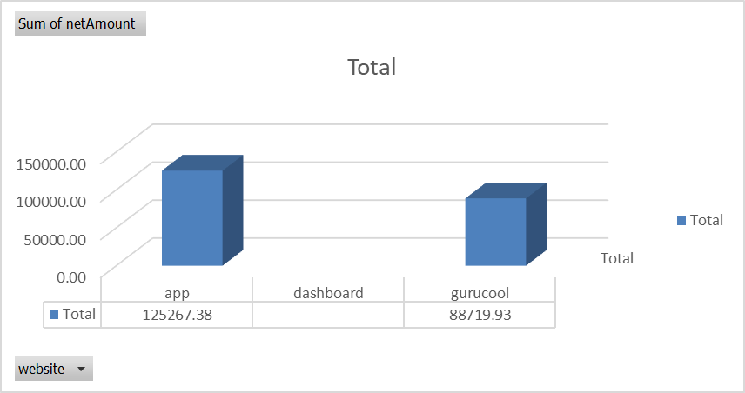

1. **How many calls were made for each user ID and guru ID?**

**Ans :** Total8365 calls were made by each userID and GuruID

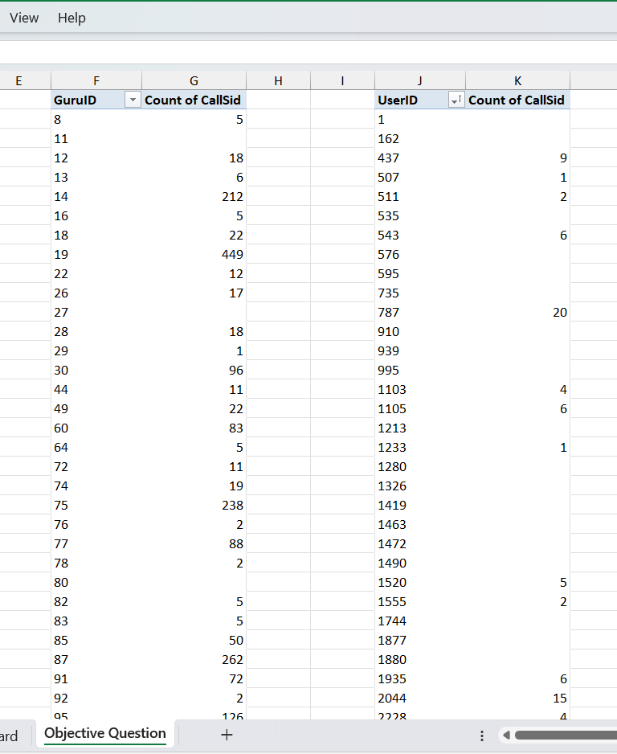

11)**What is the correlation between call duration and customer satisfaction?**

**Ans :** Corelation is -0.0002

By using formula :

=CORREL('Working Sheet'!AO:AO,'Working Sheet'!AP:AP)

CORREL(Range of UserOnCallDuration, Range of Ratings)

The correlation between call duration and customer satisfaction in this case is -0.0002, which is very close to zero. This suggests that there is effectively no meaningful relationship between how long a call lasts and the customer’s level of satisfaction.

1. **Which guru have the highest and lowest customer satisfaction scores?**

**Ans :**

**Astro Pujaa Rai and Tarot Mystical** has the highest number of average rating

**Tarot Rittika** has lowest customer satisfaction score because this astro

average rating is lowest

Calculated using below pivot table : by applying aggregate function on

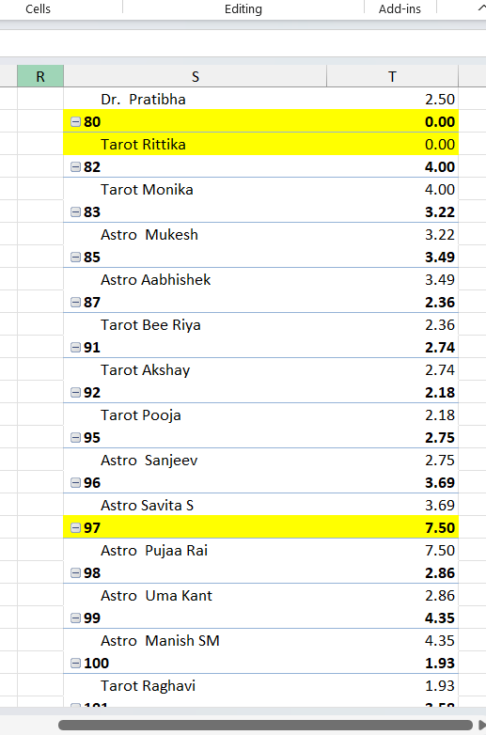 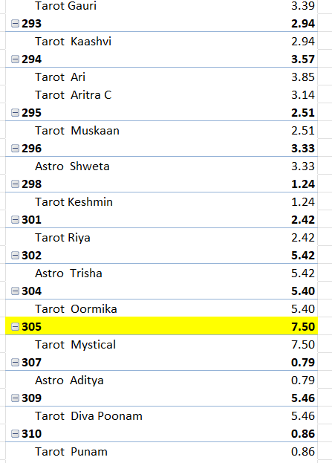

1. **What is the average customer satisfaction score by month?**

**Ans :**

1. **How many categorical columns are there in the data? [Search about categorical and continuous data, and try to answer this question]**

Ans : consultationType, website,chatStatus, refundStatus, isWhiteListUser, queue, freeCall, freeChat, callChannel, callIvrType, callStatus, astrologerCallStatus, region, userCallStatus, rating are categorical columns

**Subjective Question:**

1. **Should the investment be used to hire more agents, improve training programs, or upgrade call center technology?**

Ans :

**Approach :**

**Check whether hiring more agents is needed :** Count of guru id - I have taken a pivot table to count the guru id

Count of calls is calculated as below using countif function

=COUNTIF(data!$H:$H,"Call") + COUNTIF(data!$H:$H,"public_live_Call")

Count of days = i have calculate by fetching unique values of date and then doing count of it =UNIQUE(R2:R28028) = 34 total days

Count of calls/(count of guru id * count of days) = **1.91** Calls are handled per agent per day

**Refrence Image :**

As average no of calls attended by one agent per day is 1.91 so i dont think of to hire more agents instead some agents are getting less rating so definitely

training programs should improve

=COUNTIF(AQ2:AQ28028,">5")

A significant portion of sessions received a rating of 0, indicating dissatisfaction or unresolved sessions.(Calculated by applying filter on ratings column)

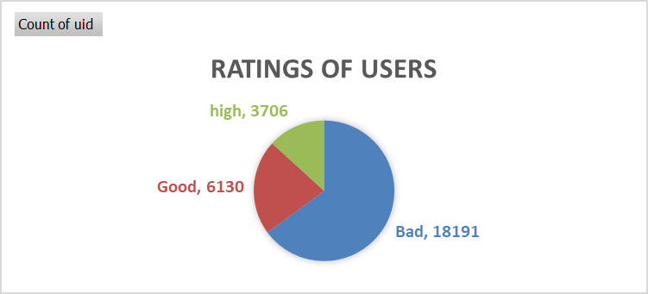

**Improving Training Programs**

There are total 28027 records and out of that only **3706** has got more than 6 and **6130** has got more than 4 rating so according to my approach

(How i have given good,bad and high rating using if formula here it is

=IF(AM2>6,"high",IF(AM2<4,"Bad","Good"))

**Insight:** Above chart shows that while some agents are performing well, a significant portion received ratings below satisfactory levels. Specifically:

* **High Ratings:** Only 3,706 sessions received a rating above 6.
* **Good Ratings:** 6,130 sessions received a rating above 4.
* **Low Ratings:** Many sessions had a rating of 0, indicating possible customer dissatisfaction or unresolved issues.

**Upgrading Call Center Technology**

To evaluate the need for technology upgrades, a **pie chart was created** comparing the number of Call and Chat consultations.

### **Key Insights from the Chart:**

* **Calls**: 8,508 consultations (**30%**)
* **Chats**: 19,514 consultations (**70%**)

Despite fewer calls, **calls generate significantly more revenue** compared to chats (as seen in the revenue charts on the dashboard). However, a major problem is that **over 26% of calls fail due to “Busy” status**, especially during peak hours (7–11 AM and 4–6 PM).  
  
**Recommendations for Technology Upgrades**:

* Implement **smart call routing** to avoid busy signals.
* Use **callback features** to reduce failed call attempts.
* Deploy **AI-based chatbots** for routine queries.
* Shift to **cloud-based call center systems** for better scaling and monitoring.

**Final Recommendations**

Based on the data analysis and visual insights:

* **Do not hire more agents**: Current agents are handling very low daily call volumes, indicating underutilization of the existing workforce.
* **Improve training programs**: Focus on agents who consistently receive low ratings in order to enhance their performance and increase overall customer satisfaction.
* **Upgrade call center technology**:
  + Reduce call failures during peak hours
  + Improve operational efficiency and resource allocation
  + Align service delivery with user preferences and channel behavior.

**Conclusion**:  
The investment of 1 crore should be strategically allocated to:

* Training programs (to improve service quality)
* Technology upgrades (to enhance efficiency and customer experience)  
  Rather than hiring additional agents.

1. **What are the potential risks of each investment option (hiring, training, technology upgrades), and how can they be mitigated?**

**Name the chart/spreadsheet function you will use for solving the problem?**

Ans :

**Risk for hiring :**

High costs would be there to hire new employees because training of that new

Employees will be high

Underperformance or Mismatch:

New hires may not meet performance expectations, or their skills might not align

with job requirements, leading to inefficiencies.

**Mitigation**:

* **Structured Hiring Process**: Implementing rigorous screening, assessments, and interviews to ensure the right fit.
* **Trial Periods**: Offering a probationary period to assess fit before making long-term commitments.
* **Employee Retention Programs**: Investing in employee engagement, development, and competitive compensation to reduce turnover rates.

**Ineffectiveness of Training Programs**:

If the training doesn’t address specific skills needed or isn’t aligned with the actual operational challenges, the return on investment may be low.

**Mitigation**:

**Post-Training Support**: Provide continuous mentoring and coaching to reinforce the training and ensure its implementation.

**Risk of Technology Upgrades:**

**Risks**:

* **High Upfront Costs**: Technology upgrades such as AI-powered chatbots or IVR systems can require a significant initial investment.

A thoughtful balance of hiring, training, and technology investments can help AstroSage optimize its call center, but careful planning is necessary to mitigate risks.

1. **How does AstroSage call center performance compare to that of AstroGuru in terms of average call volume, customer satisfaction, and agent performance?**

**Will you use any aggregation function or a visualization here to solve the problem**?

Ans : Not able to answer this question, not understood the question

1. **How can the call center improve its handling of peak call periods to ensure high customer satisfaction?**

**Mention the functionality which you will use for giving the suggestions, will it be any aggregated function or a visualization?**

Ans:

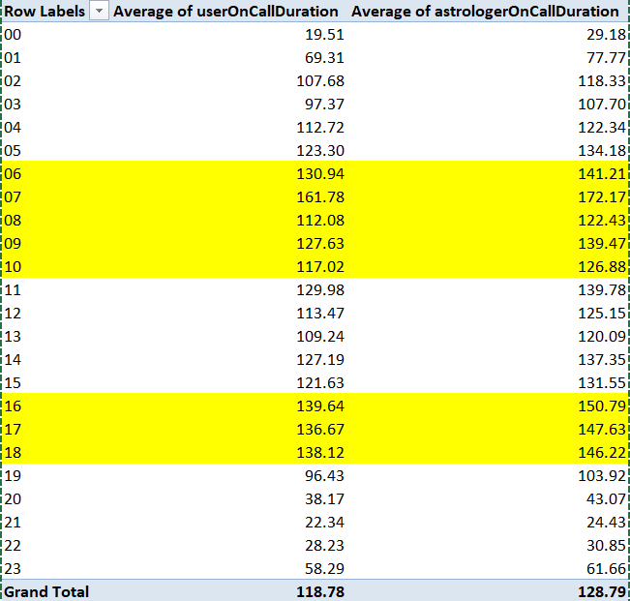

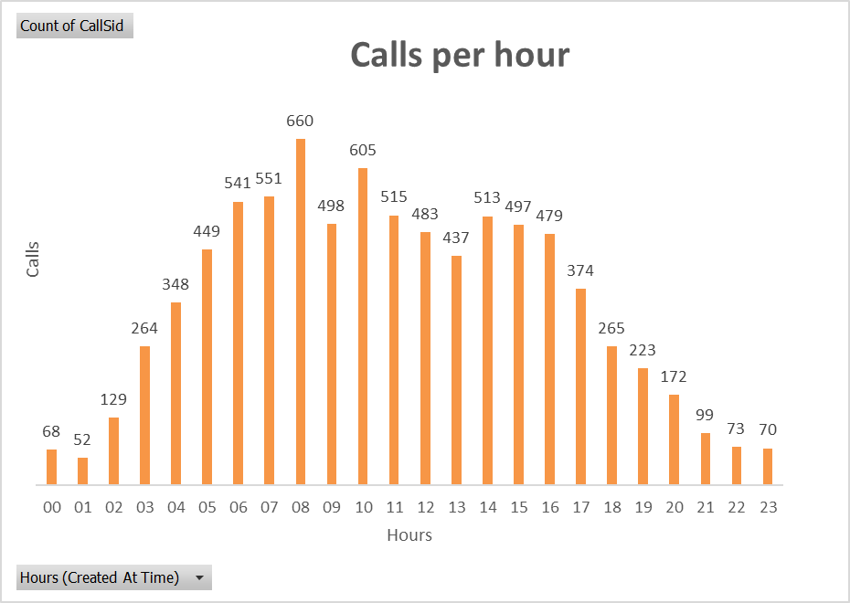

Based on the insights from both the pivot tables and the call volume chart:

Approach : **Identify Peak Hours with Aggregation Functions**:

* Using the COUNT() function on Call IDs, we've identified that the peak call volume occurs around 7 AM to 10 AM and around 4 PM to 6 PM.
* Additionally, the AVERAGE() function for userOnCallDuration and astrologerOnCallDuration shows higher average call durations around these hours. This could indicate a backlog or complex calls requiring longer handling times.

Recommendations:**Increase Staffing During Peak Times**:

* Since both call volume and call duration are high during the identified peak hours, the call center could benefit from scheduling additional agents around 6 AM to 10 AM and 4 PM to 6 PM. This could reduce waiting times and prevent agents from becoming overwhelmed, contributing to a smoother experience for customers.
* Calls during peak hours tend to be longer, possibly due to complex queries or slower resolution times. By using skill-based routing, more experienced agents can handle complex issues first, potentially reducing overall call time and improving customer satisfaction.

1. **Based on historical data, what strategic initiatives should be prioritized to improve overall efficiency and customer satisfaction?**

Ans : **Insight from Dashboard:**

—>The chart "Consultation vs Call Status" shows a significant number of incomplete and failed calls. Addressing this could greatly improve customer satisfaction.

—>"Rating of Unique Gurus" indicates that while some gurus perform exceptionally well, others may need training or better resource management. The chart shows a wide variance in the ratings received by gurus.

1. **What can be the key factors contributing to high customer satisfaction scores, and how can these be leveraged to improve overall performance?**

**What is the basis for the suggestions? And mention how did you decide if the satisfaction score affect the ratings?**

Ans :

**Call Status (Completed Calls)**

* **Factor**: Successful call completions likely lead to higher customer satisfaction, as customers appreciate effective resolutions.
* **Dashboard Insight**: The “Call Status" chart shows a high number of "Completed" calls, which might correlate positively with higher satisfaction scores.
* **Actionable Strategy**: Focus on maintaining or increasing completed call rates by optimizing agent performance, training on common issues, and providing effective solutions during calls. Address failure reasons such as "no-answer" or "incomplete" to reduce their occurrence, which would further improve satisfaction.

### **2. User Ratings (Rating of Gurus)**

* **Actionable Strategy**: Identify top-rated astrologers and analyze their methods or communication style. Use these insights to guide other agents, applying best practices across the team to ensure consistently high satisfaction levels.
* Here is the chart of guru who performed well

### **3. Consultation Type**

* **Factor**: Certain consultation types may lead to higher satisfaction due to their specific structure or level of detail. The "Consultation vs Users" chart highlights the volume of different consultation types.
* **Dashboard Insight**: If one type, such as "Calls," is more frequently used and has high satisfaction, this format might be preferred by users for its direct interaction.
* **Actionable Strategy**: Consider prioritizing and improving popular consultation types. For less popular types with lower satisfaction, you could gather feedback to understand why they aren’t as favored and make adjustments.

1. **How should the call center balance the workload among agents to ensure optimal performance and avoid burnout?**

**Mention your approach and spreadsheet function for the answer?**

Ans :

To improve agent workload distribution and ensure both optimal performance and agent well-being, we can take a data-driven approach based on the metrics we've gathered. Here’s an overview of the approach and how each metric supports balanced scheduling:

### **1. Current Agent Workload Calculation**

* **Average Calls Handled per Agent per Day**: We calculated this by taking the total number of calls divided by the product of the total number of agents and days. With this calculation, we found that, on average, each agent handles approximately 1.91 calls per day.
* This metric helps set a baseline. By knowing the expected calls per agent, we can identify when agents are handling above or below this average, potentially indicating overwork or underutilization.

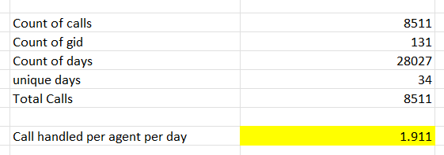

### **Identifying High-Demand Periods**

* We used pivot tables to determine the call volume and average call duration for each hour of the day. From these, we can see specific peak periods with high call volumes and potentially longer call durations, which may signal more complex issues or slower response times.
* **Recommendation**: Schedule more agents during peak hours (e.g., early mornings and late afternoons). This targeted approach ensures that agents aren’t overloaded during busy times, which can lead to burnout and reduced customer satisfaction.

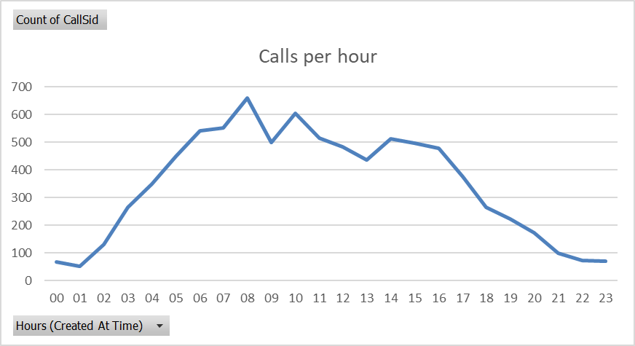

1. **What new technologies or tools could be implemented to enhance call center operations and customer service?**

Ans :

**AI-Powered Chatbots**: Automate common queries and provide 24/7 support, reducing the load on human agents and improving response times.

### **Cloud-Based Call Centers**

* Moving call center operations to the cloud enables better scalability, flexibility, and cost efficiency.
* Cloud platforms provide remote access for agents, making it easier to implement work-from-home models and quickly scale up or down based on call volumes.

1. **What metrics should be included in the final dashboard to provide a comprehensive view of call center performance and guide investment decisions?**

Ans:

**Filters that I have included in the final dashboard are**

* Category Website
* Consultation Type
* Months(CreatedAT)

KPI’s that I have included in the final dashboard are

* Total Sessions
* Total Users
* Total Revenue
* Total Gurus

Visualizations that I have included in the final dashboard are

**Bar Chart**

* Rating count of Gurus
* Top 10 Guru with High Rating
* Consultation vs Users
* Chat/Call REVENUE
* Calls per hour

**Pie Chart**

* Consultation wise revenue
* Call Status completed vs busy
* Ratings of users
* Percentage of total Sales for each Category

**Line Chart**

* No of calls per Day

All the above metrics will help in comprehensively viewing call center performance and guide investors to take correct investment decisions.

1. **How would you allocate a 1 crore rupee investment to optimize operational efficiency, enhance customer satisfaction, and boost profitability, and what analysis-based recommendations would you offer to support this?**

[you have to give bullet pointers in order to answer this question]

Ans:

**Upgrade Call Handling and Routing Technology**

* Invest in smart routing systems to efficiently direct calls based on agent expertise and customer needs, helping to reduce wait times and improve service quality. Approximately ₹30-35 lakhs.

**Boost Staffing and Training Programs**

* Increase the number of agents available during peak periods and provide comprehensive training to improve communication and conflict resolution skills. Around ₹20-25 lakhs.

**Implement Customer Feedback Mechanisms**

* Set up a system to collect and analyze customer feedback for continuous service improvement and satisfaction tracking. Allocate around ₹15-20 lakhs.

**Enhance Infrastructure and Equipment**

* Invest in reliable call center equipment and network upgrades to ensure smooth, uninterrupted service. About ₹10-15 lakhs.

**Develop Self-Service Channels**

* Create self-help options like FAQs and chatbots to reduce call volume for simpler inquiries, freeing up agents for more complex calls. Estimated at ₹10-15 lakhs.